In the sales pipeline, when I click on a card, I want to see all of the information in both of these snips. Not a pop up. It should take me to a page that has all of these details associated with the deal, grouped by card the way that this is shown. This should be a subpage of the Pipeline page.
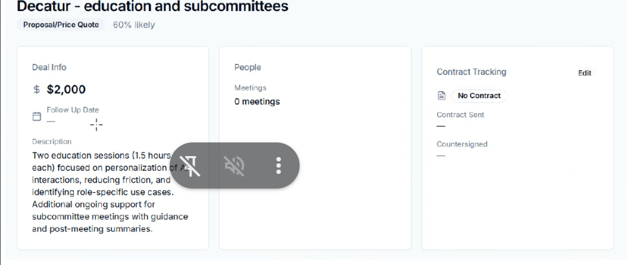
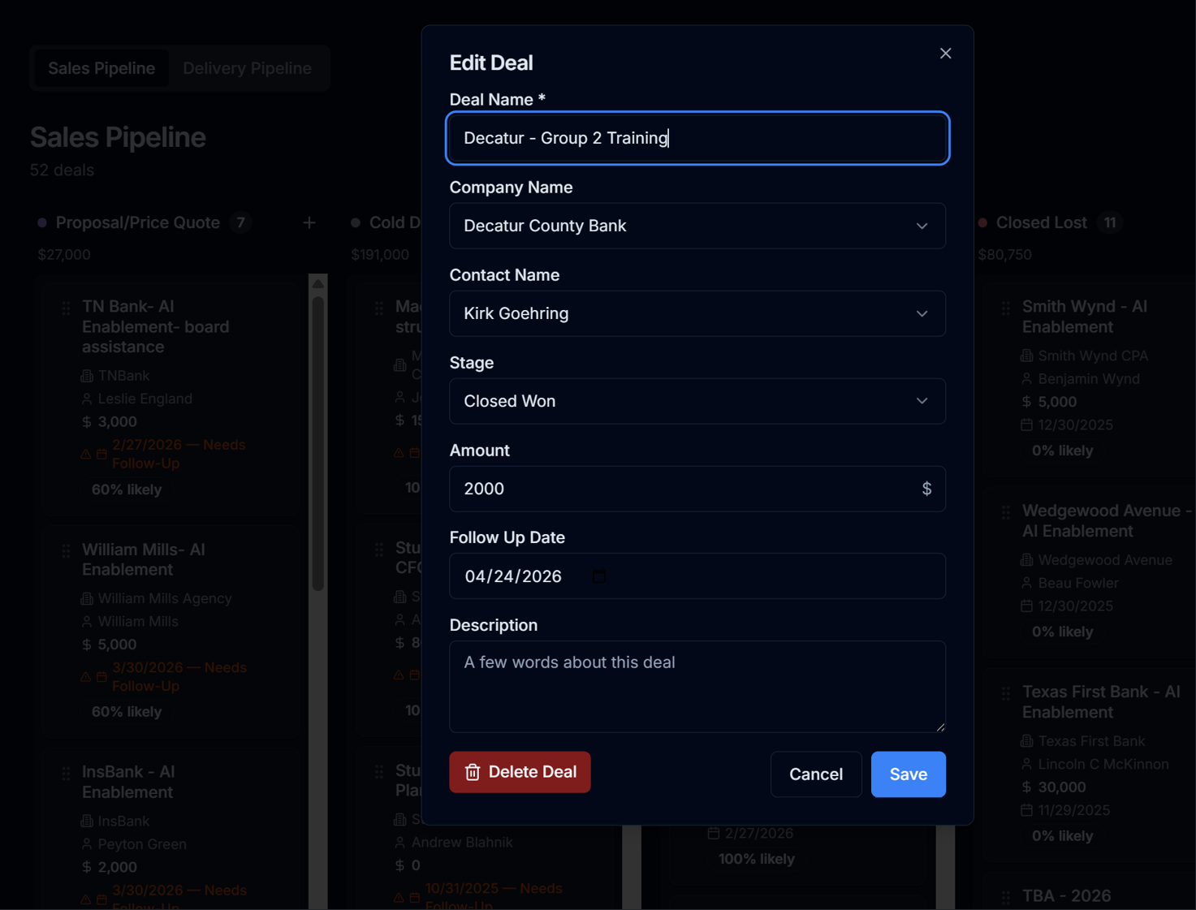

Keep the same style. Move the Cold Deal, Closed Won, Closed Lost, and Service Complete to a separate sub page to the right of Delivery Pipeline. It should be called Archived Pipeline.

Remove the Likelihood for all of these. They shouldn’t be captured in the Pipeline metrics since they are no longer in the pipeline.
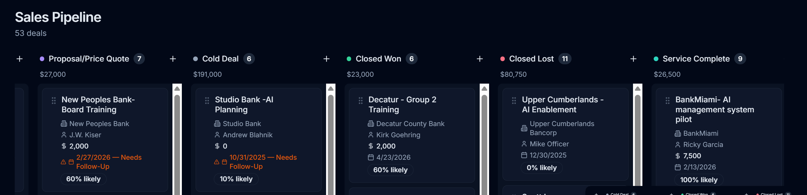

Currently, the GCal n8n workflow is only identify a meeting existed or exists. It needs to capture information on the meeting. Type, location, other attendees, subject and any information in the meeting message body.
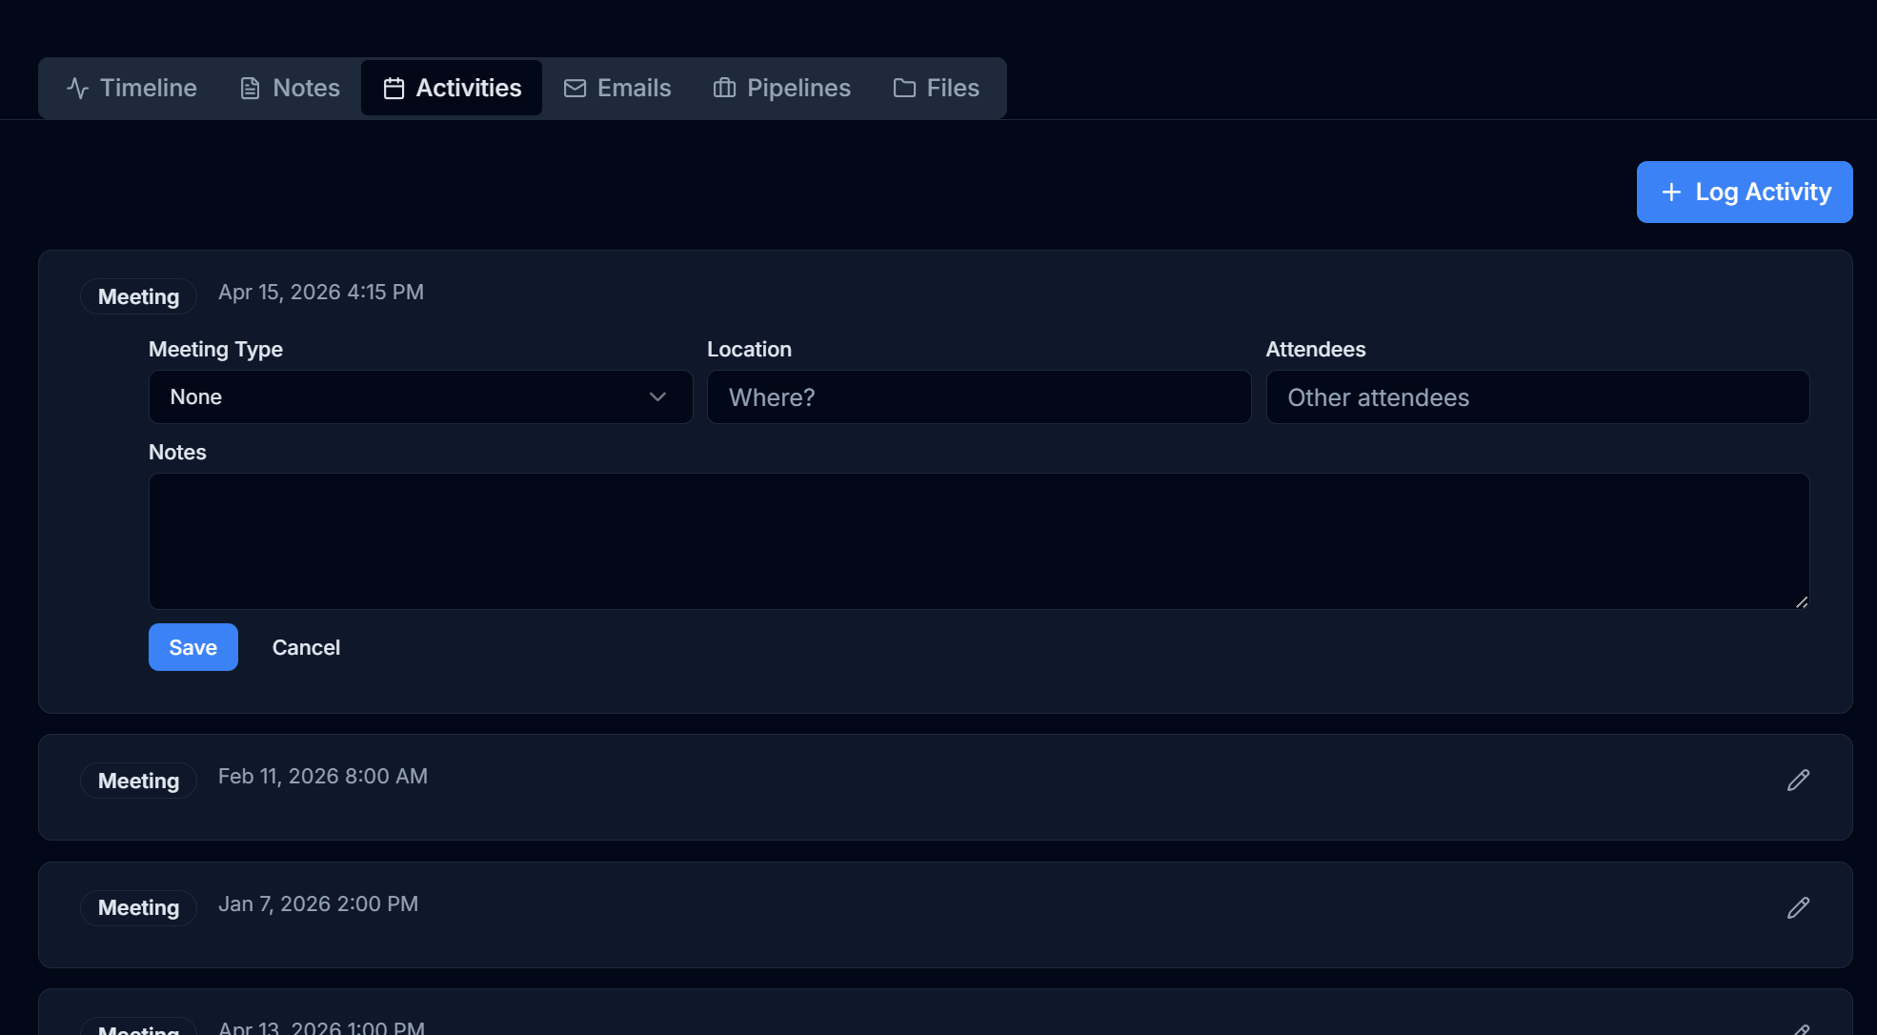

If I ask Andrea to log a note for someone, or add an activity, etc, she should be able to write to the contact card or the company information. Really I want her to be able to write to any input within the web app.
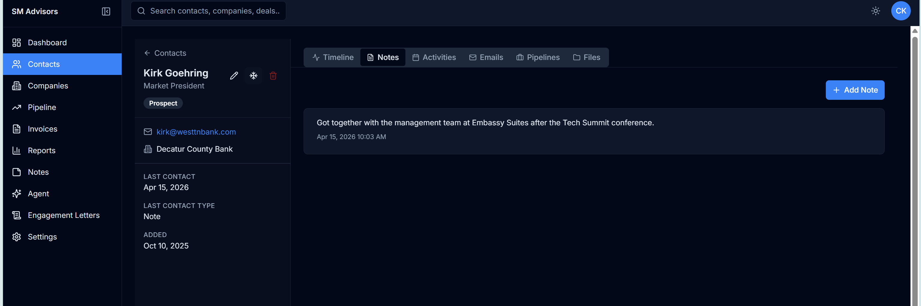

On the contacts and companies pages, just make all items viewable in one page. I don’t have enough items in each page to bog down the system. Also do this for the Invoices page.
Also, the Contacts number for each company in the list view here is not updating based on the number of contacts inside the Company card.
And make all columns except for company name editable in the list view by clicking in the “cell”. And remove the ability to delete company’s from this screen. Delete should only occur inside the company card itself.
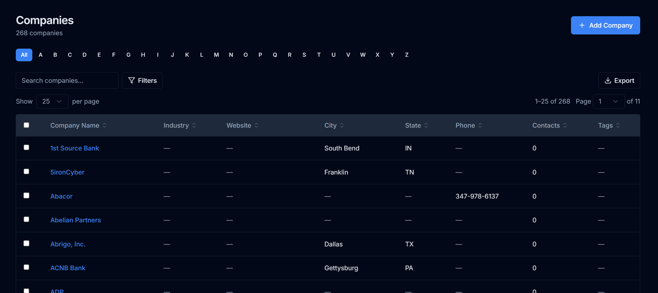

“Notes” shouldn’t be considered activity for purposes of Last Activity Date
Also, I want the ability to add “Reminders”. Add that to the right of Emails in the view of each contact card. I want to set up Twilio to shoot me a text message when the timing of a reminder comes up. Also make sure Andrea can write reminders.
Let me know what else needs to be set up with Twilio to send those text messages.
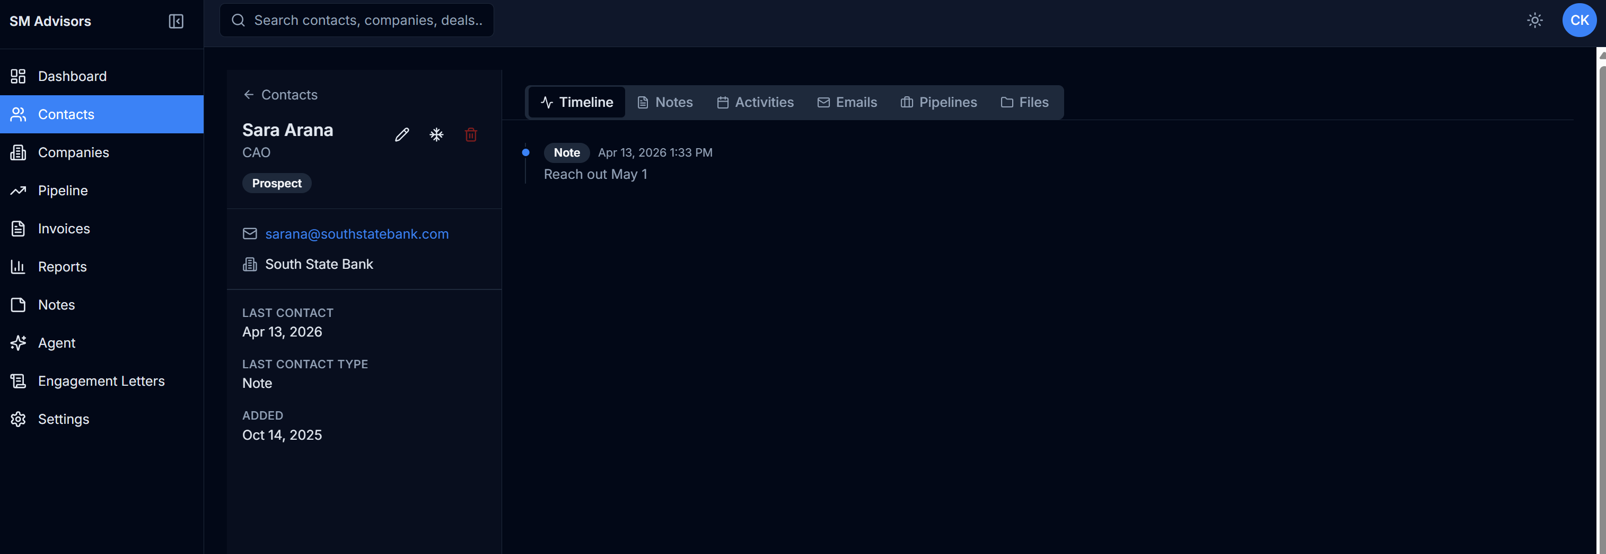

We aren’t using Perplexity for anything. Remove that everywhere.
